**Assignment -2**

IBM CLOUD DB2

|  |  |
| --- | --- |
| Assignment Date | 29 September 2022 |
| Team Lead | Karthick.S |
| Student Roll Number | 721719104303 |
| Maximum Marks | 2 Marks |

**Questions:**

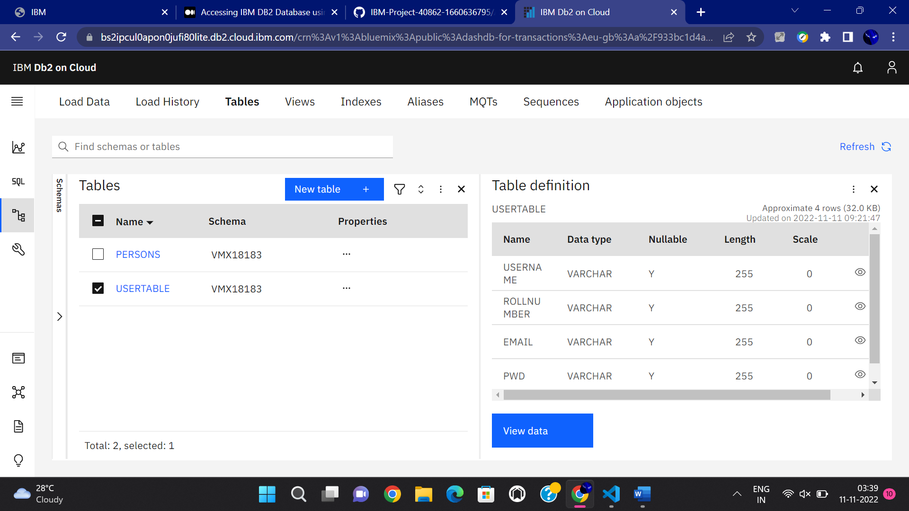

1. Create User table with user with email, username, roll number, password.

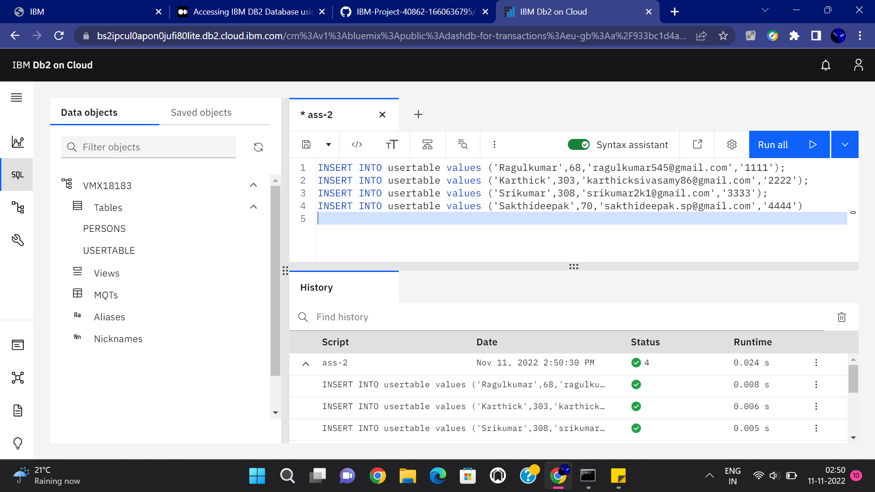

1. Perform UPDATE,DELETE Queries with user table.

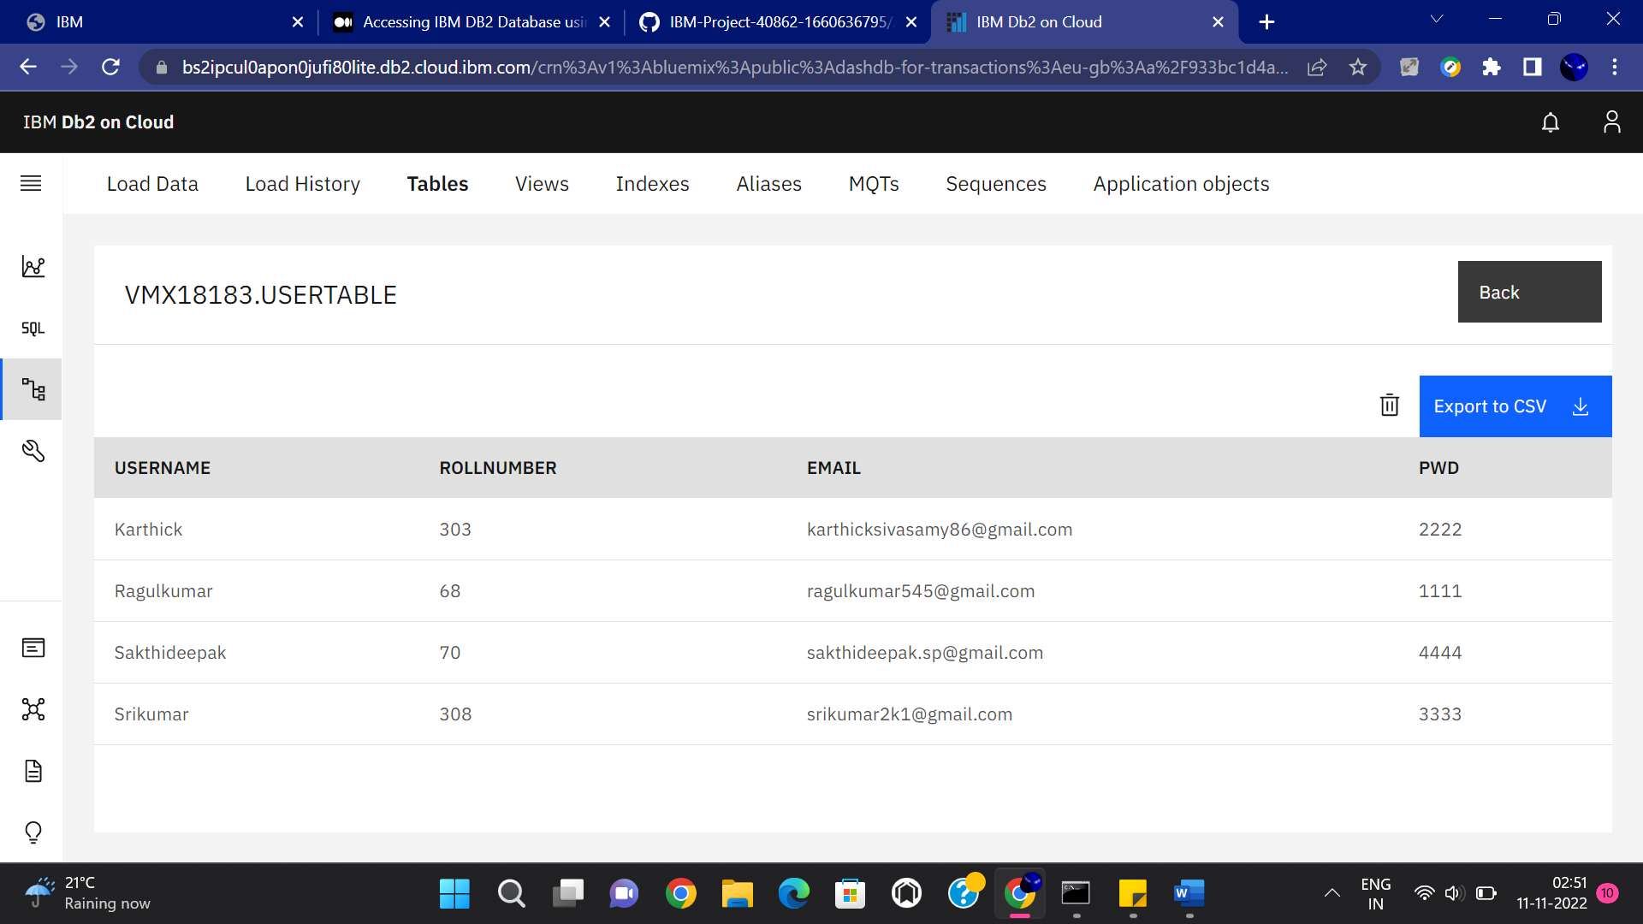

3.Connect python code to db2.

**NOTE:- Question 4 contains Question 3 answer**

4. Create a flask app with registration page, login page and welcome page. By default load the registration page once the user enters all the fields store the data in database and navigate to login page authenticate user username and password. If the user is valid show the welcome page

**Answers**

**App.py**

**from flask import Flask, render_template, request, redirect, url_for, session**

**import ibm_db**

**import re**

**app = Flask(__name__)**

**app.secret_key = 'a'**

**conn = ibm_db.connect(**

**"DATABASE=bludb;HOSTNAME=fbd88901-ebdb-4a4f-a32e-9822b9fb237b.c1ogj3sd0tgtu0lqde00.databases.appdomain.cloud;PORT=32731;USERNAME=dtp46044;PASSWORD=95soX0sZGhb4ToUj;SECURITY=SSL;SSLSERVERCERTIFICATE=DigiCertGlobalRootCA.crt;", "", "")**

**@app.route("/", methods=['GET', 'POST'])**

**def register():**

**msg = ''**

**if request.method == 'POST':**

**username = request.form['username']**

**email = request.form['email']**

**password = request.form['password']**

**sql = "SELECT * FROM users WHERE username =?"**

**stmt = ibm_db.prepare(conn, sql)**

**ibm_db.bind_param(stmt, 1, username)**

**ibm_db.execute(stmt)**

**account = ibm_db.fetch_assoc(stmt)**

**print(account)**

**if account:**

**msg = 'Account already exists !'**

**elif not re.match(r'[^@]+@[^@]+\.[^@]+', email):**

**msg = 'Invalid email address !'**

**elif not re.match(r'[A-Za-z0-9]+', username):**

**msg = 'name must contain only characters and numbers !'**

**else:**

**insert_sql = "INSERT INTO users VALUES (?, ?, ?)"**

**prep_stmt = ibm_db.prepare(conn, insert_sql)**

**ibm_db.bind_param(prep_stmt, 1, username)**

**ibm_db.bind_param(prep_stmt, 2, email)**

**ibm_db.bind_param(prep_stmt, 3, password)**

**ibm_db.execute(prep_stmt)**

**msg = 'You have successfully registered !'**

**elif request.method == 'POST':**

**msg = 'Please fill out the form !'**

**return render_template('register.html', msg=msg)**

**@app.route('/login', methods=['GET', 'POST'])**

**def login():**

**global userid**

**msg = ''**

**if request.method == 'POST':**

**username = request.form['username']**

**password = request.form['password']**

**sql = "SELECT * FROM users WHERE username =? AND password=?"**

**stmt = ibm_db.prepare(conn, sql)**

**ibm_db.bind_param(stmt, 1, username)**

**ibm_db.bind_param(stmt, 2, password)**

**ibm_db.execute(stmt)**

**account = ibm_db.fetch_assoc(stmt)**

**print(account)**

**if account:**

**session['loggedin'] = True**

**session['id'] = account['USERNAME']**

**userid = account['USERNAME']**

**session['username'] = account['USERNAME']**

**msg = 'Logged in successfully !'**

**msg = 'Logged in successfully !'**

**return render_template('dashboard.html', msg=msg)**

**else:**

**msg = 'Incorrect username / password !'**

**return render_template('login.html', msg=msg)**

**if __name__ == '__main__':**

**app.run(host='0.0.0.0')**

**# app.run(debug=True)**

**Register.html**

**<!DOCTYPE html>**

**<html lang="en">**

**<head>**

**<meta charset="UTF-8">**

**<meta http-equiv="X-UA-Compatible" content="IE=edge">**

**<meta name="viewport" content="width=device-width, initial-scale=1.0">**

**<title>Smart Fashion register</title>**

**<!-- bootstrap css cdn -->**

**<link rel="stylesheet" href="https://stackpath.bootstrapcdn.com/bootstrap/4.5.2/css/bootstrap.min.css"**

**integrity="sha384-JcKb8q3iqJ61gNV9KGb8thSsNjpSL0n8PARn9HuZOnIxN0hoP+VmmDGMN5t9UJ0Z" crossorigin="anonymous">**

**<link rel="stylesheet" href="https://cdnjs.cloudflare.com/ajax/libs/font-awesome/4.7.0/css/font-awesome.css">**

**<!-- css stylesheet -->**

**<link rel="stylesheet" href="/static/css/style.css">**

**<!-- font styles cdn -->**

**<link rel="preconnect" href="https://fonts.gstatic.com">**

**<link href="https://fonts.googleapis.com/css2?family=Alegreya&display=swap" rel="stylesheet">**

**<link href="https://fonts.googleapis.com/css2?family=Alegreya:wght@600&display=swap" rel="stylesheet">**

**</head>**

**<body>**

**<!-- bootstrap navbar -->**

**<!-- navbar ends -->**

**<!-- Login form -->**

**<div class="login text-center mt-5">**

**<form action="/" method="post">**

**<h2 class="form-text-h2"> Register Form </h2>**

**<div class="msg">{{ msg }}</div>**

**<input type="text" class="form-control" name="username" placeholder="Enter Your Username" id="username"**

**required>**

**<input type="email" class="form-control" name="email" placeholder="Enter Your Email ID" id="email" required>**

**<input type="password" class="form-control" name="password" placeholder="Enter Your Password" id="password"**

**required>**

**<button type="submit" id="button" class="btn btn-primary"> Register </button>**

**<div class="note mt-3 text-center">**

**<!--Register form -->**

**<p> already have an account ? please login <a href="/login">login! </a> </p>**

**</div>**

**</form>**

**</div>**

**</body>**

**</html>**

**Login.html**

**<!DOCTYPE html>**

**<html lang="en">**

**<head>**

**<meta charset="UTF-8">**

**<meta http-equiv="X-UA-Compatible" content="IE=edge">**

**<meta name="viewport" content="width=device-width, initial-scale=1.0">**

**<title>Smart Fashion Login</title>**

**<!-- favicon -->**

**<!-- <link rel="shortcut icon" href="/assets/img/favicon.ico" type="image/x-icon"> -->**

**<!-- <link rel="icon" href="/assets/img/favicon.ico" type="image/x-icon"> -->**

**<link rel="icon" type="image/png" sizes="16x16" href="/assets/img/favicon-32x32.png">**

**<!-- bootstrap css cdn -->**

**<link rel="stylesheet" href="https://stackpath.bootstrapcdn.com/bootstrap/4.5.2/css/bootstrap.min.css"**

**integrity="sha384-JcKb8q3iqJ61gNV9KGb8thSsNjpSL0n8PARn9HuZOnIxN0hoP+VmmDGMN5t9UJ0Z" crossorigin="anonymous">**

**<link rel="stylesheet" href="https://cdnjs.cloudflare.com/ajax/libs/font-awesome/4.7.0/css/font-awesome.css">**

**<!-- css stylesheet -->**

**<link rel="stylesheet" href="/static/css/style2.css">**

**<!-- font styles cdn -->**

**<link rel="preconnect" href="https://fonts.gstatic.com">**

**<link href="https://fonts.googleapis.com/css2?family=Alegreya&display=swap" rel="stylesheet">**

**<link href="https://fonts.googleapis.com/css2?family=Alegreya:wght@600&display=swap" rel="stylesheet">**

**</head>**

**<body>**

**<div class="login text-center mt-5">**

**<form action="/login" method="post">**

**<h2 class="form-text-h2"> Login Form </h2>**

**<div class="msg">{{ msg }}</div>**

**<div class="form-group mb-3">**

**<label class="label" for="username">Username</label>**

**<input type="text" class="form-control" placeholder="Username" name="username" required>**

**</div>**

**<div class="form-group mb-3">**

**<label class="label" for="password">Password</label>**

**<input type="password" class="form-control" placeholder="Password" name="password" required>**

**</div>**

**<button type="submit" id="button" class="btn btn-primary"> Login </button>**

**<div class="note mt-3 text-center">**

**<!--Register form -->**

**<p> Don't have an account yet? Click here to <a href="/">register! </a> </p>**

**</div>**

**</form>**

**</div>**

**</body>**

**</html>**

**Style.css**

**\* {**

**margin: 0;**

**padding: 0;**

**}**

**body {**

**background-color: aqua !important;**

**display: flex;**

**flex-direction: column;**

**align-items: center;**

**justify-content: center;**

**}**

**form {**

**display: flex;**

**flex-direction: column;**

**align-items: center;**

**justify-content: center;**

**background-color: white;**

**width: 40%;**

**height: 450px;**

**border-radius: 50px;**

**margin: 100px;**

**gap: 25px;**

**}**

**h2 {**

**font-size: large;**

**font-weight: bolder;**

**}**

**input {**

**width: 80% !important;**

**}**

**div {**

**display: flex;**

**align-items: center;**

**justify-content: center;**

**flex-direction: column;**

**width: 90%;**

**}**

**.form-text-vk {**

**font-size: small;**

**padding-bottom: 10px;**

**}**

**.form-text-h2 {**

**font-size: x-large;**

**padding-top: 10px;**

**}**

**Output:-**

**registration page:-**

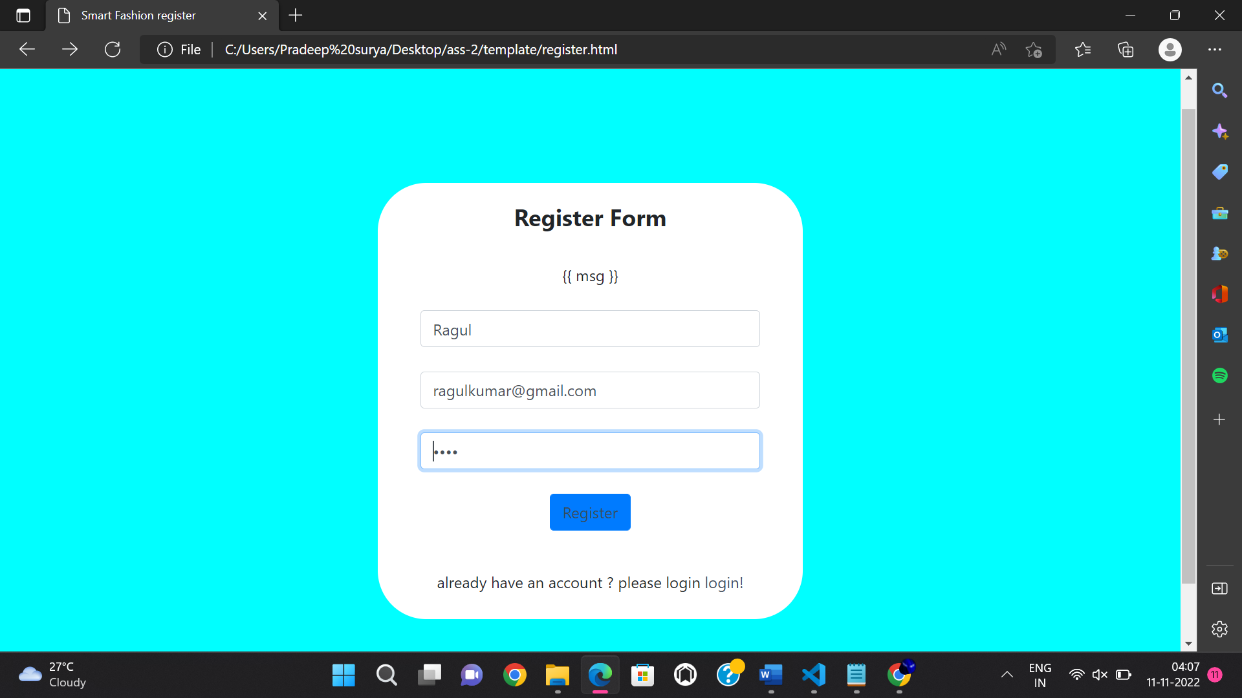

**Login Page:-**

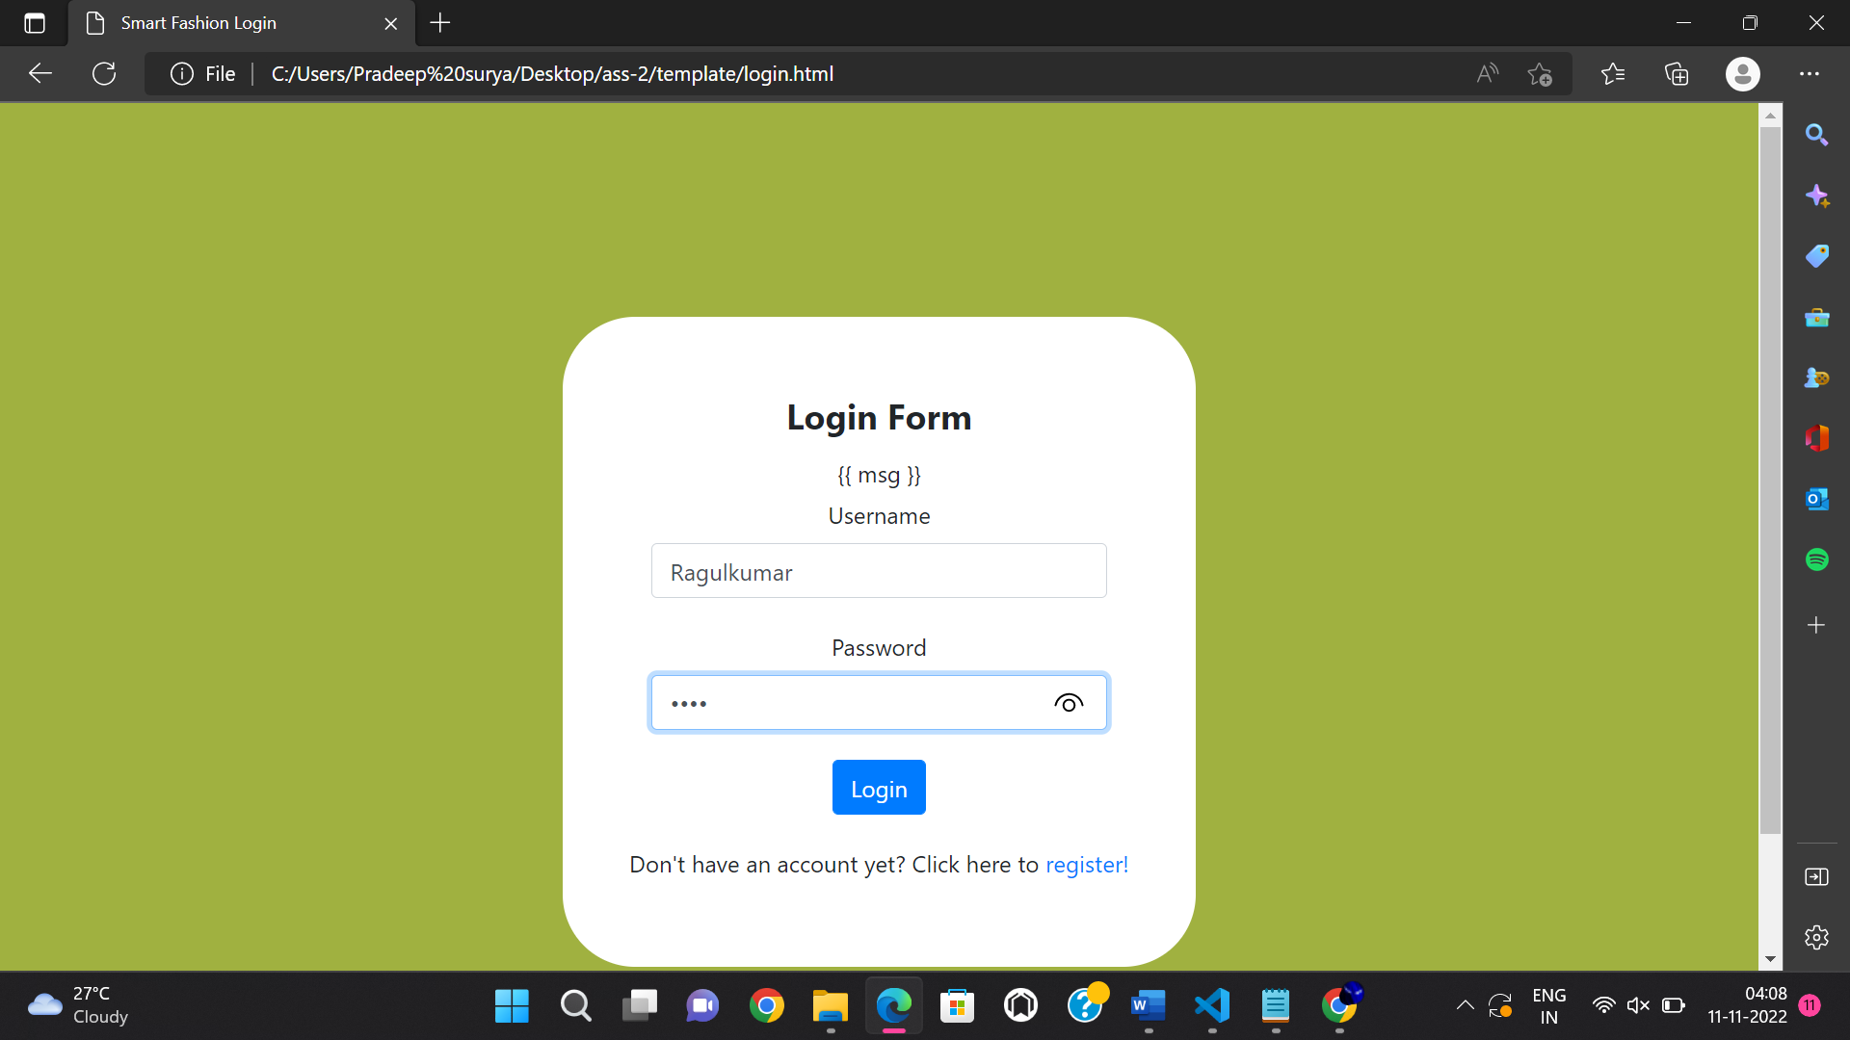

**Welcome Page:-**

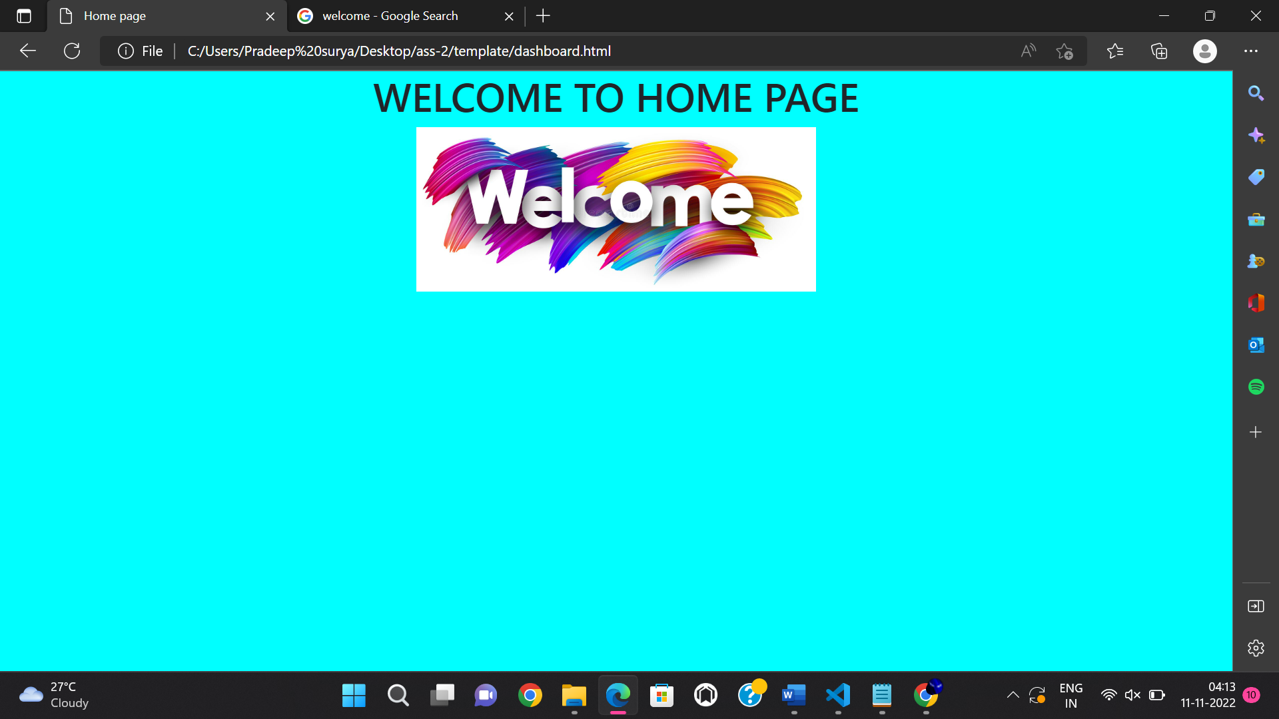

**Data Base Table :-**

